Name

Mathematics Stage 5 Paths
Inequalities

Book 1 |  | Version: 261002  Feedback:  https://MrDingMaths.com
Contents
Syllabus Content 2
Learning Intention 3

Syllabus Content
MA5-EQU-P-01 solves monic quadratic equations, linear inequalities and cubic equations of the form $ax^{3}=k$
Solve linear inequalities and graph their solutions on a number line
- Represent inequalities on a number line
- Solve linear inequalities, including those with negative numbers, and graph the solutions
- Recognise that an inequality has an infinite number of solutions unless other restrictions are introduced

Inequalities

- Inequalities
- $x>3$ means “$x$ is greater than 3.”
- We show inequalities on a number line using:
  - Arrows pointing right for larger values.
  - Arrows pointing left for smaller values.
  - An open circle (○) for "less than" ($<$) or "greater than" ($>$).
  - A closed circle (●) for "less than or equal to" ($≤$) or "greater than or equal to" ($≥$).
Less than | 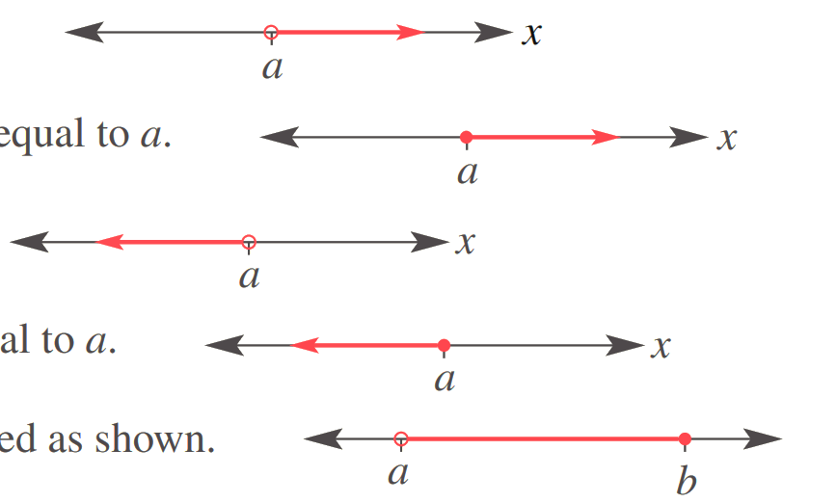  More than
$$x<a$$ | $$x>a$$
Less than or equal to | More than or equal to
$$x≤a$$ | $$x≥a$$

- Identify Inequality on a number line
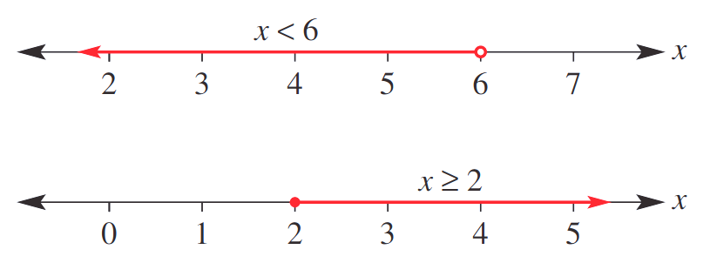  $$x<6$$ | $$x≥2$$
Identify the inequality shown.
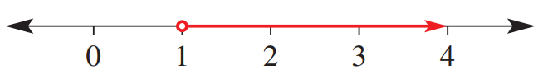 | 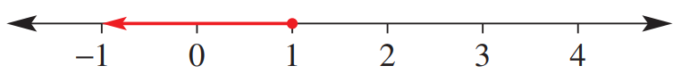
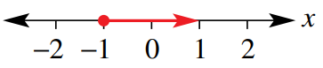
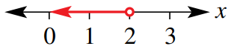

Foundation
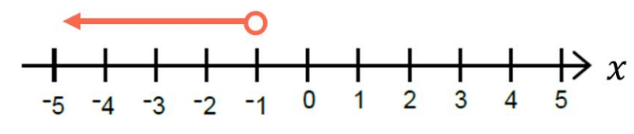
- Which inequality is represented by the diagram?

A | $x<-1$ | B | $x≤-1$ | C | $x>1$ | D | $x≥-1$

- Which inequality is represented by the diagram?
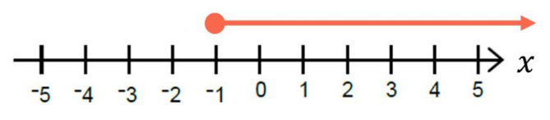

A | $x<-1$ | B | $x≤-1$ | C | $x>1$ | D | $x≥-1$

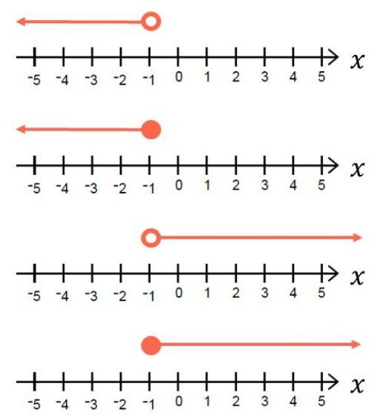
- Which diagram represents $x≤-1$?

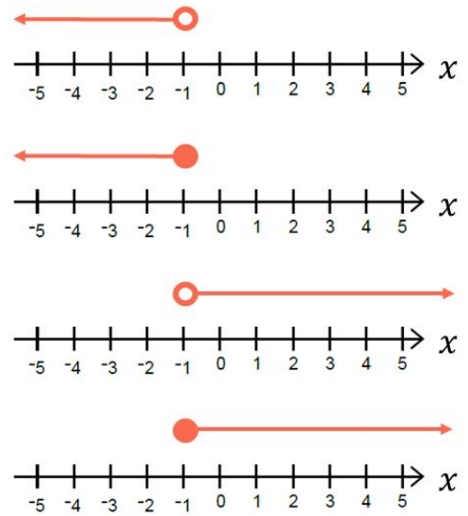
- Which diagram represents $x>-1$?

- Read the examples carefully and answer the questions.
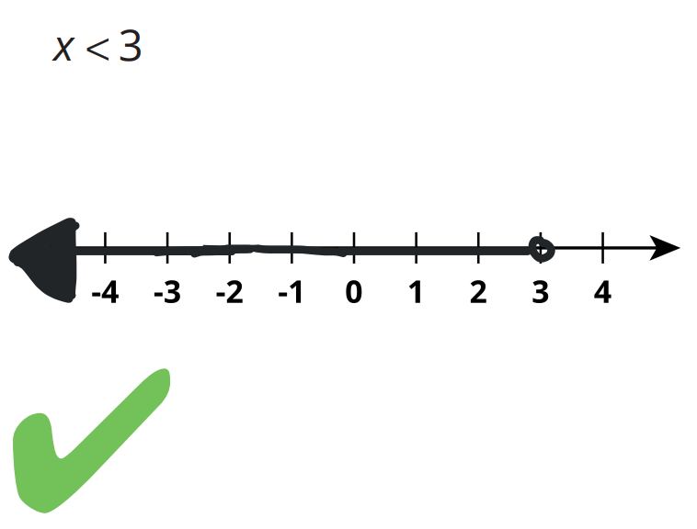  Lina’s work: | How did Lina know which way to draw her arrow?  $x<3$ means “$x$ ……… than 3”, so the arrow should point to the ………… of 3.  Why did Lina make the circle around the 3 open instead of closed?  $<$ means the 3 is ………… an included value.  Show $x≥3$  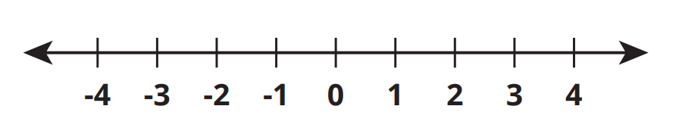
Nevaeh’s work:  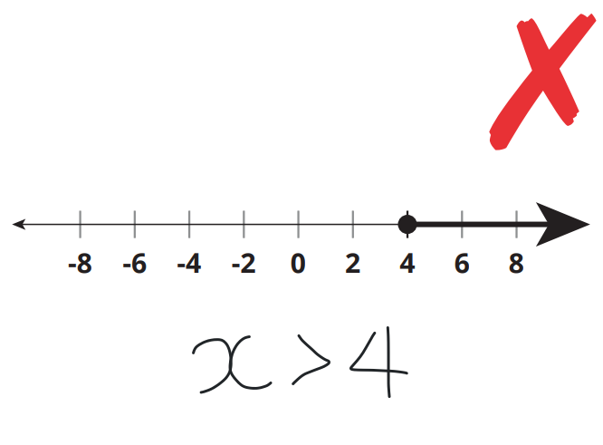 | What part of the inequality that Nevaeh wrote is incorrect?  $>$ should be ………, because of the closed circle.  Write the inequality shown by this region:  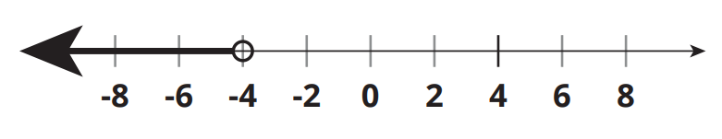  $$x<-4$$
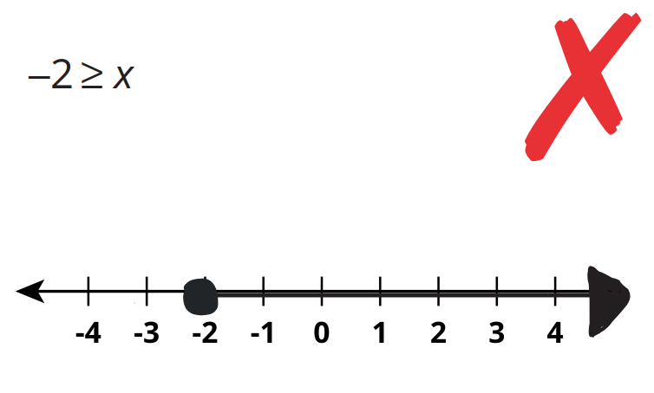  Terrance’s work: | How do you know that Terrance’s arrow is pointed in the wrong direction?  $-2≥x$ means “$x$ ……… than or equal to $-2$”, so the arrow should point to the ………  Show $2<x$  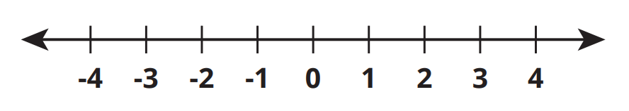
Franco’s work:  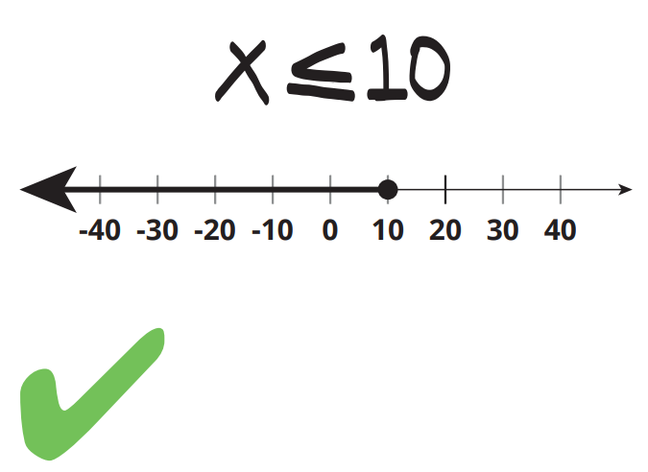 | If Franco had written 10 ≥ x, would his answer still be correct? Explain.  ………, the two expressions are equivalent.  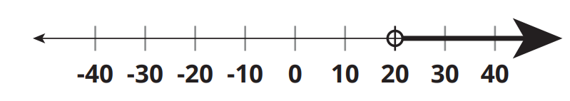  Write the inequality shown by this region:
Lance’s work:  Write as an inequality:  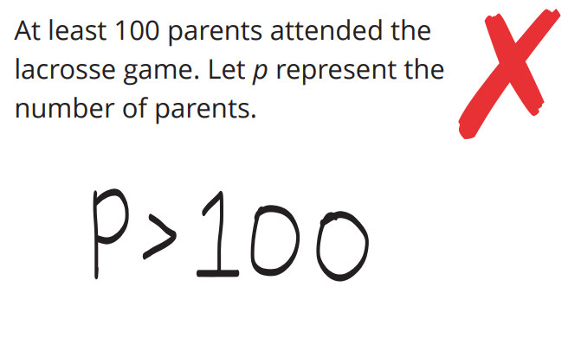 | Lance should have written ≥. Which words in the question show that Lance’s answer is wrong?  “…… …………… 100” means 100 is included.  Write as an inequality:  The candy store has no more than 24 flavours of jellybeans. Let $f$ represent the number of flavours.  $$f≤24$$
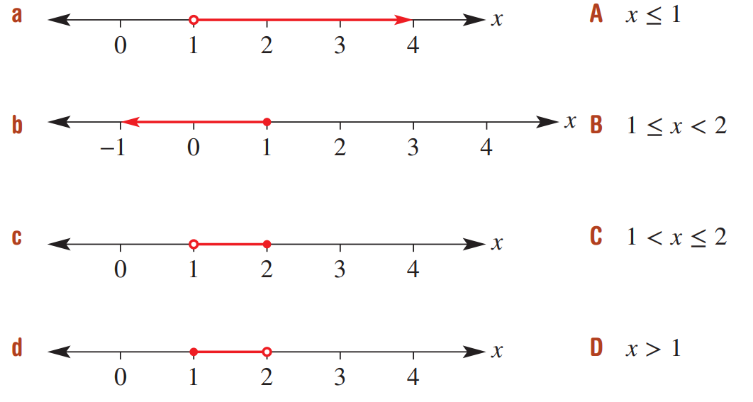
- Match the number line with the inequality.

a – D, b – A, c – C, d – B
- Indicate these regions on the number line.
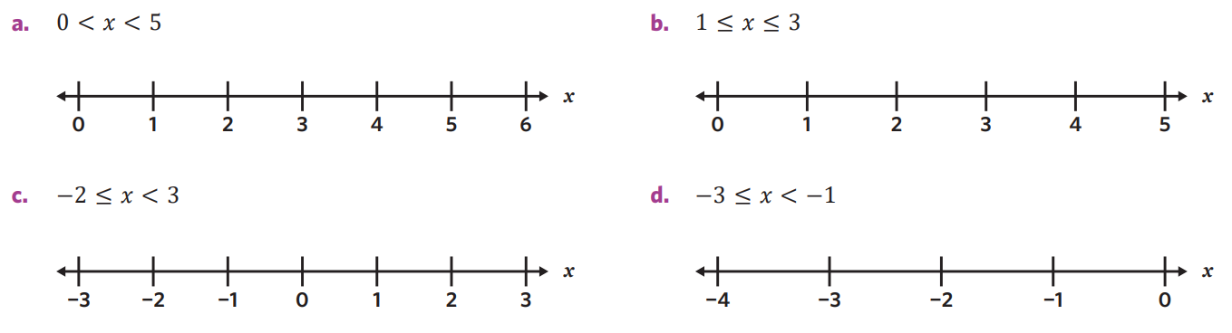

- State the inequality shown by these number lines.
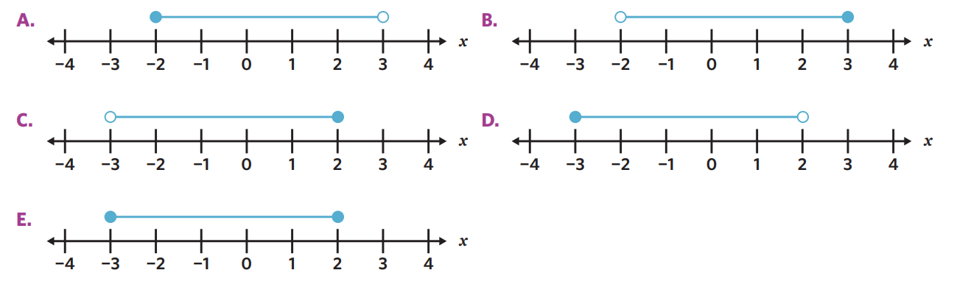  $$-2≤x<3$$ | $$-2<x≤3$$
$$-3<x≤2$$ | $$-3≤x<2$$

Solving Inequalities Part 1

- Working with inequalities
Compare these numbers using inequality symbols.
3 5  $+1 +1$  4 6  $-8 -8$  $-4$ $-2$  Do we change the inequality sign when adding or subtracting? | 3 5  $×3 ×3$  9 15  $÷2 ÷2$  4.5 $7.5$  Do we change the inequality sign when multiplying or dividing by a positive number? | 3 5  swap  5 3  Do we change the inequality sign when swapping LHS and RHS?

- Solving Inequalities
- Inequalities have infinite solutions.
For example, $x>3$ could be $x=3.1, 4, 792$, but not $3$, $2$ or $-4$.
- When we solve an inequality, we solve for the solution set.

- Solve inequalities the same way as equations: apply inverse operations to both sides.
- Isolate the pronumeral.
- Write the pronumeral on the LHS.
If you swap LHS and RHS, flip the inequality symbol.

- Example Solve inequalities involving positive coefficients
$y+1>10$1. Isolate $-1= -1$ $y>9$  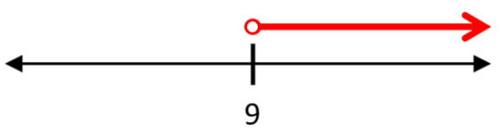 | $-1≤2a-3$  1. Isolate $+3= +3$ $2≤2a$  $1≤a$  2. LHS $a≥1$  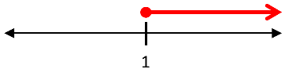

- Guided Practice
Solve these inequalities and graph the solution set.
- $x+5<8$  $-5 -5$  $x<$ ……  $$x<3$$ | - $-12+m<-7$  $$m<5$$ | - $3m-7<11$  $$m<6$$
- $4+3x>-8$  $$x>-4$$ | - $\frac{x}{2}$ $-5≤3$  $$x≤16$$ | - $\frac{2x-3}{5}$ $>9$  $$x>24$$

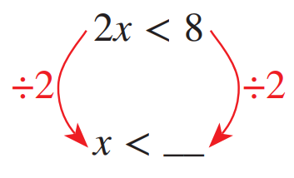
Foundation
- Complete the following:

Therefore, what is the solution to $2x<8$?
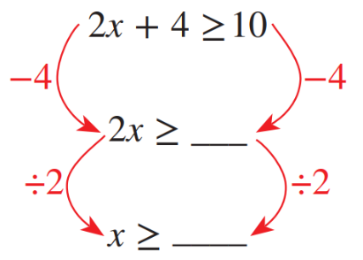
$x<4$
- Complete the following:

Therefore, what is the solution to $2x+4≥10$?
$$x≥3$$
- Solve these inequalities.
- $x+9>12$  $$x>3$$ | - $x+5<8$  $$x<3$$ | - $b-2>3$  $$b>5$$
- $y-8>-2$  $$y>6$$ | - $-12+m<-7$  $$m<5$$ | - $5x≥15$  $$x≥3$$
- $4t>-20$  $$t>-5$$ | - $\frac{x}{3}$ $≥4$  $$x≥12$$ | - $12≤6+4a$  $$a≥\frac{3}{2}$$

- Solve these inequalities, then show the solution set on a number line.
- $2x<10$  $$x<5$$ | - $x+2>10$  $$x>8$$ | - $x-2>10$  $$x>12$$
- $\frac{x}{2}$ $≤10$  $$x≤20$$ | - $\frac{x}{4}$ $≥10$  $$x≥40$$ | - $x+4≥10$  $$x≥6$$
- $x-4<10$  $$x<14$$ | - $4x≥10$  $$x≥\frac{5}{2}$$ | - $4x≤60$  $$x≤15$$

- Read the examples carefully and answer the questions.
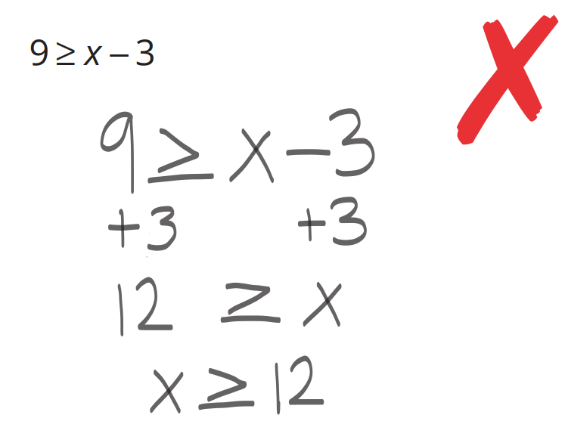  Maria’s work: | Maria wanted to write the $x$ first in her solution. What did she forget to change?  If you swap LHS and RHS, you need to …………… the inequality symbol.  $12 ≥ x$ and $x ≥ 12$ mean two different things. Show the meaning of both using a number line.  Solve:  $$-9<x-3$$  $-6<x$ or $x>-6$

- Solve these inequalities.
- $\frac{d-9}{2}$ $>10$  $$d>29$$ | - $\frac{y+4}{2}$ $≤7$  $$y≤10$$ | - $\frac{x-3}{4}$ $>2$  $$x>11$$
- $2<$ $\frac{x-3}{4}$  $$x>11$$ | - $\frac{2x+4}{3}$ $>6$  $$x>7$$ | - $\frac{7+3h}{2}$ $<5$  $$h<1$$
- $\frac{q+4}{2}$ $≥11$  $$q≥18$$ | - $11≤$ $\frac{q+4}{2}$  $$18≤q$$ | - $4≥$ $\frac{4+6p}{4}$  $$2≥p$$

Development
- Wendy is $x$ years old and Jay is 6 years younger.
The sum of their ages is less than 30.
Write an inequality involving $x$ and solve it. What can you say about Wendy’s age?

$$x+\left(x-6\right)<30$$
Wendy is younger than 18
- The perimeter of a particular rectangle needs to be less than 50 cm.
If the length of the rectangle is 12 cm and the breadth is $b$ cm.
What values can be breadth of the rectangle be?
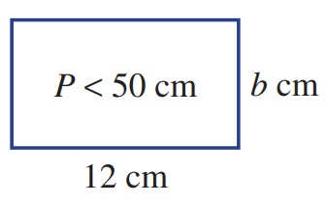

$$2b+24<50$$
$$b<13$$
But since breadth must be positive, $b$ is between 0 and 13 cm
$$0<b<13$$
- The breadth of a rectangle is 10 m and the height is $(2x-4)$ m.
If the area is less than 80 m², what are the possible whole number values for $x$?

$$10\left(2x-4\right)<80$$
$$x<6$$
$x$ can be 1, 2, 3, 4, 5 m
- Explain why $x>4$ and $x≥5$ are not the same inequality.

$x>4$ includes values such as 4.3 whereas $x≥5$ does not.
- Solve these inequalities.
$$t<3$$ | $$t≤9$$ | 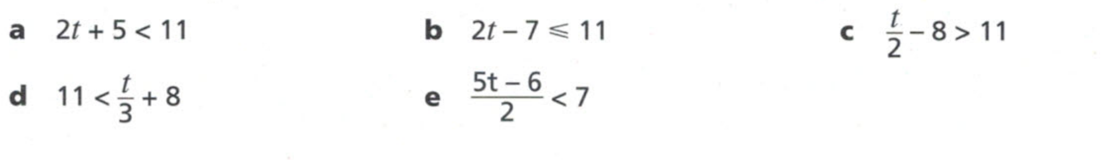  $$t>38$$
$$t>9$$ | $$t<4$$

Mastery
- Solve these equations.
- $\frac{n}{4}$ $+3=5$  $$n=8$$ | - $\frac{n+3}{4}$ $=5$  $$n=17$$ | - $n+$ $\frac{3}{4}$ $=5$  $$n=\frac{17}{4}$$ | - $\frac{2n+3}{4}$ $=5$  $$n=\frac{17}{2}$$ | - $\frac{2n+3}{4}$ $=-5$  $$n=-\frac{23}{2}$$

- Solve these inequalities.
- $6+$ $\frac{p}{5}$ $>2$  $$p>-20$$ | - $\frac{6}{5}$ $+p<2$  $$p<\frac{4}{5}$$ | - $\frac{6+p}{5}$ $≥2$  $$p≥4$$ | - $\frac{p+6}{5}$ $≤-2$  $$p≤-16$$ | - $-2>$ $\frac{2p-5}{6}$  $$p<-\frac{7}{2}$$

- Solve these inequalities.
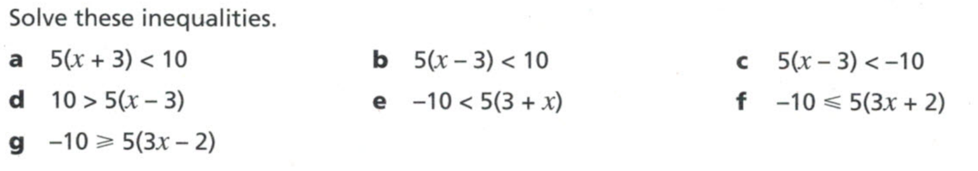  $$x<-1$$ | $$x<5$$ | $$x<1$$
$$x<5$$ | $$x<-5$$ | $$x≤-\frac{4}{3}$$

- The cost of a helicopter ride is $59 plus $12 per km. Form an inequality to find the greatest number of whole kilometres you can ride in the helicopter with a budget of $150.

$$12n+59<150$$
$$n≤7.583$$
7 km
- A box contains dark chocolates, milk chocolates and white chocolates in the ratio 1:3:2.
There are fewer than 40 chocolates in the box.
What is the maximum possible number of each chocolate in the box?

$$x+3x+2x<40$$
$$x<6.\dot{6}$$
6 dark choc, 18 milk choc, 12 white choc

Solving Inequalities Part 2

- Working with inequalities
Compare these numbers using inequality symbols.
3 5  $×-1 ×-1$  $-3$ $-5$  $×-5 ×-5$  15 $25$  Do we change the inequality sign when multiplying by a negative number? | 30 60  $÷-5 ÷-5$  $-$6 $-$12  $÷-2 ÷-2$  $3$ $6$  Do we change the inequality sign when dividing by a negative number? | $-3$ $-5$  swap  $-5$ $-3$  Do we change the inequality sign when swapping LHS and RHS?

- Example Solve inequalities involving negative coefficients
Solve these inequalities
$-x≤-9$  $÷-1= ÷-1$  $x≥9$  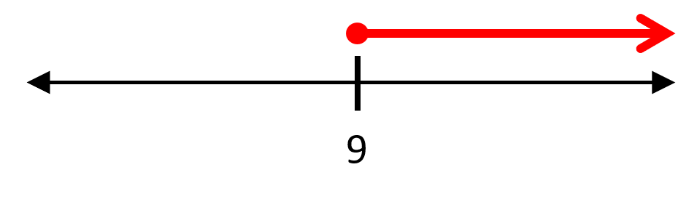 | $$5-2x>3 \\ -5= -5 \\ -2x>-2 \\ ÷-2= ÷-2$$ $x<1$  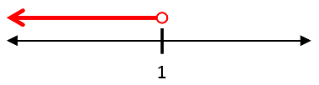

- Guided Practice
Solve these inequalities.
- $-x>15$  $÷-1 ÷-1$  $x$ … ……  $$x<-15$$ | - $-3x≤-12$  $$x≥4$$ | - $4-x<16$  $$x>-12$$
- $51>-7x$  $$x>-\frac{51}{7}$$ | - $12≥15-x$  $$x≥3$$ | - $5-$ $\frac{x}{4}$ $<13$  $$x>-32$$

- Key Ideas
- When ……………… or ………………… by a negative number, we …………… the inequality sign.

Foundation
- Solve the following inequalities involving negative numbers.
Remember to reverse the inequality when multiplying or dividing by a negative number.
- $6-2x<4$  $$x>1$$ | - $24-6s≥12$  $$s≤2$$ | - $43-4n>23$  $$n<5$$
- $34-2j<14$  $$j>10$$ | - $2-9v≤20$  $$v≥-2$$ | - $2-7j≤37$  $$j≥-5$$
- $48-8c≥32$  $$c≤2$$ | - $42-8h≤42$  $$n≥0$$ | - $7-8s>31$  $$s≤-3$$

- Look at the examples carefully and answer the questions.
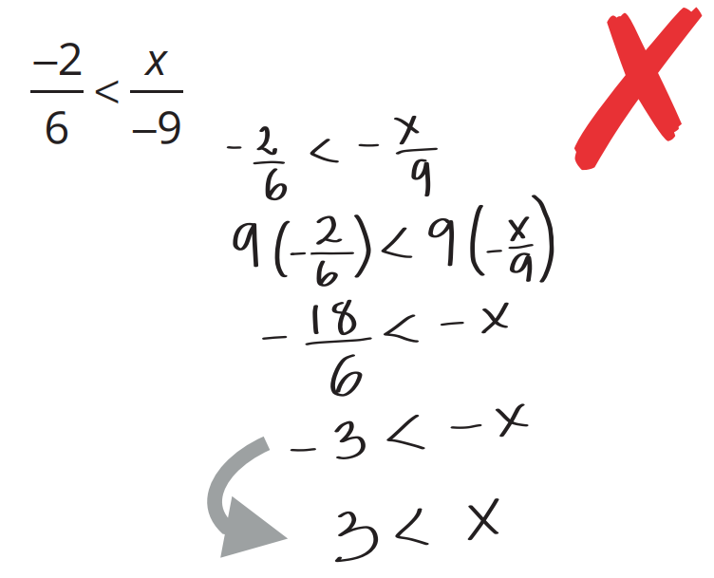 | Explain why it’s not okay to just cancel out the negative signs in the step marked with an arrow.  To cancel negative signs, you are dividing both sides by ………, so you must reverse the inequality sign.  What is the correct answer?  $3>3$ or $x<3$  Solve  $$-\frac{2}{4}≤\frac{x}{-6}$$  $$x≤3$$
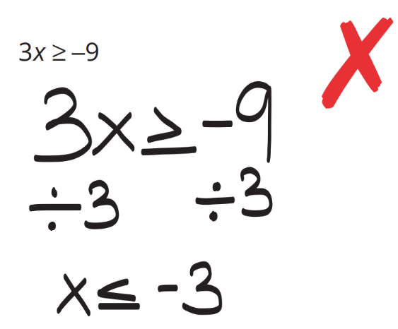  Chantelle’s work: | By substituting $x=-4$ into the inequality, show that Chantelle is wrong.  Chantelle incorrectly switched the symbol. Why do you not switch the symbol here?  Chantelle didn’t divide by a ……………, so she didn’t need to switch the symbol.  Solve:  $$4x≤-20$$  $$x≤-5$$

- Solve these inequalities.
- $2x+5<9$  $$x<2$$ | - $10≥2x-5$  $$x≤\frac{15}{2}$$ | - $5-5x≤-10$  $$x≥3$$
- $2x+5>9$  $$x>2$$ | - $2x-5≥-10$  $$x≥ -\frac{5}{2}$$ | - $6-5x≤-10$  $$x≥\frac{16}{5}$$
- $9>2x+5$  $$x<2$$ | - $x-5≥-10$  $$x≥-5$$ | - $-5x+6≤-10$  $$x≥\frac{16}{5}$$
- $10>2x+5$  $$x<\frac{5}{2}$$ | - $5-x≥-10$  $$x≤15$$ | - $-5x-6≤-10$  $$x≥\frac{4}{5}$$
- $10≥2x+5$  $$x≤\frac{5}{2}$$ | - $5-x≤-10$  $$x≥15$$ | - $-5x-6≤10$  $$x≥-\frac{16}{5}$$

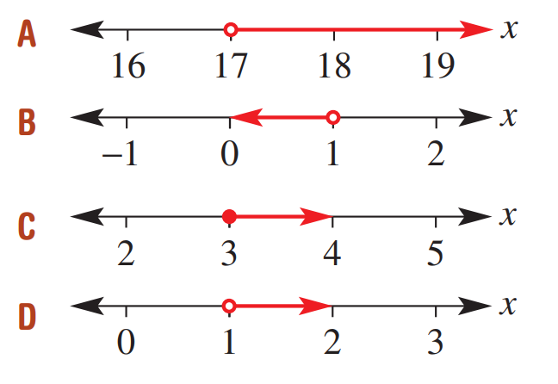
- Match the number line with the inequality.
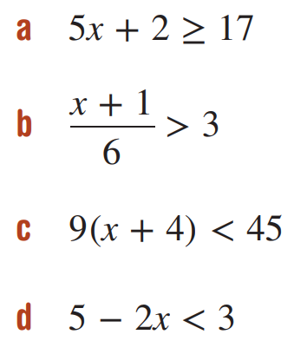

a – C, b – A, c – B, d - D

Development
- To say that a number $x$ is positive is to say that $x > 0$.
  - If $10x-40$ is positive, find all the possible values of $x$. That is, solve $10x - 40 > 0$.

$$x>4$$
  - Find all $k$ values that make $2k - 6$ positive.

$$k>3$$
  - If $3a+6$ is negative and $10-2a$ is positive, what are the possible values of $a?$

$a<-2$ and $a<5$
$∴a<-2$ satisfies both conditions
  - If $5a+10$ is negative and $10a+30$ is positive, what are the possible values of $a$?

$a<-2$ and $a>-3$
$-3<x<-2$ satisfies both conditions

  - Prove that if $5x-2$ is positive, then $x$ is positive.

$$x>\frac{2}{5}, so x must be positive as x>0$$
  - Prove that if $2x+6$ is positive, then$x+5$ is positive.

$$x>-3$$
$∴x+5>2; so x must be positive as x>0$
- Issy and Stella are solving the inequality $6-3y>10-5y$

I’m going to add $3y$ to both sides first.


I’m going to add $5y$ to both sides first.

Use both methods to solve the equation. Whose method is more sensible?
$$6-3y>10-5y$$ | $$6-3y>10-5y$$
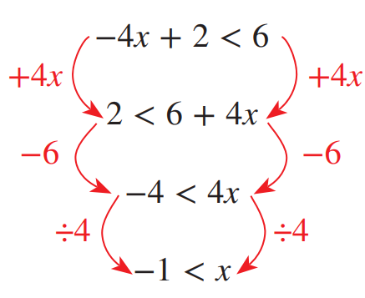
- Multiplying or dividing by a negative number can be avoided by adding the pronumeral to the other side of the equation. For example:

This can then be rearranged to $x>-1$
- $12<-3c$  $$c<-4$$ | - $-5x+20<10$  $$x>2$$ | - $12-2a≥16$  $$a≤-2$$
- $12x+5≤10x+11$  $$x≤3$$ | - $7a+3>6a$  $$x>-3$$ | - $52b≥3b-35$  $$b≥-\frac{35}{49}$$
- $g>9g+40$  $$g<-5$$ | - $7a+12<4\left(2a+1\right)$  $$a>8$$ | - $-2\left(3k-5\right)≤5k-1$  $$k≥1$$


- Olivia and Charlotte are solving the inequality $\frac{1}{2}x+3<\frac{1}{4}x+5$
I’m going to subtract $\frac{1}{2}x$ from both sides first.

I’m going to multiply both sides by 4 first.

Use both methods to solve the equation. Which method do you prefer?
$$\frac{1}{2}x+3<\frac{1}{4}x+5$$ | $$\frac{1}{2}x+3<\frac{1}{4}x+5$$
- Solve these inequalities.
- $\frac{x}{2}$ $-5≤3$  $$x≤16$$ | - $3-$ $\frac{x}{9}$ $≥4$  $$x≤-9$$ | - $8≥$ $\frac{2x}{3}$  $$x≤12$$
- $\frac{2x+6}{7}$ $<4$  $$x<11$$ | - $\frac{3x-4}{2}$ $>-6$  $$x>-\frac{8}{3}$$ | - $3≥$ $\frac{1-7x}{5}$  $$x≥-2$$
- $4(x+2)<12$  $$x<1$$ | - $-3(a+5)>9$  $$a<-8$$ | - $25≤5(3-x)$  $$x≤-2$$
- $2(3-x)>1$  $$x<\frac{5}{2}$$ | - $5(y+2)<-6$  $$y<-\frac{16}{5}$$ | - $-11>-7(1-x)$  $$x<-\frac{4}{7}$$
- $2x+9≤6x-1$  $$x≥\frac{5}{2}$$ | - $6t+2>t-1$  $$t>-\frac{3}{5}$$ | - $7y+4≤7-y$  $$y≤\frac{3}{8}$$
- $3a-2<4-2a$  $$a<\frac{6}{5}$$ | - $1-3m≥7-4m$  $$m≥6$$ | - $7-5b>-4-3b$  $$b<\frac{11}{2}$$

- Solve these equations.
$$x=24$$ | $$x=40$$ | $$x=16$$
Solve these inequalities.
$$y<-6$$ | $$y≤30$$ | $$y<72$$

- Solve these inequalities.
- $5\left(t-1\right)<3\left(t-2\right)$  $$t<-\frac{1}{2}$$ | - $5\left(t-1\right)≥3(2-t)$  $$t≥\frac{11}{8}$$
- $5\left(1-t\right)≤3\left(t-2\right)$  $$t≥\frac{11}{8}$$ | - $5\left(1-t\right)<3(2-t)$  $$t>-\frac{1}{2}$$

- Solve these inequalities.
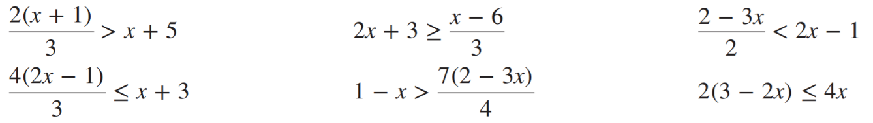  $$x<-13$$ | $$x≥-3$$ | $$x>\frac{4}{7}$$
$$x≤\frac{13}{5}$$ | $$x>\frac{10}{17}$$ | $$x≥\frac{3}{4}$$

